Guidelines for preparation of one-page
Abstract for SATAC 2021

First A. Author¹*, Second B. Author², Third C. Author^{2,3}

¹Affiliation (institution only, see example)
² University Department of Chemistry, Magadh University, Bodh Gaya 824234, India
³Aryabhatta Centre for Nanoscience & Nanotechnology, Aryabhatta Knowledge University,
Patna-800001, India
*Corresponding author: e-mail: xxx@mu.ac.in

Keywords: thermal analysis, DSC, citrate precursor, optical properties

Authors are invited to submit electronically a one-page abstract on or before December 10, 2021. Abstracts should summarize the main concepts of the work, results and conclusions.

The abstract must be written in English following the template provided. Times Roman font 11 pt must be used, with the exceptions of the title (12 pt), affiliations and references (9 pt). The text width is 130 mm and length is 200 mm. The file must be delivered as doc or docx formats, other formats are not accepted. Figure/picture [Fig. 1] or table [Table-1] if any, should be centered and located inside paper margins. Text should not wrap around figures or tables may be included Figures and tables; table captions (11-point font) should be centered above tables, and figure captions (11-point font) should be centered below figures.

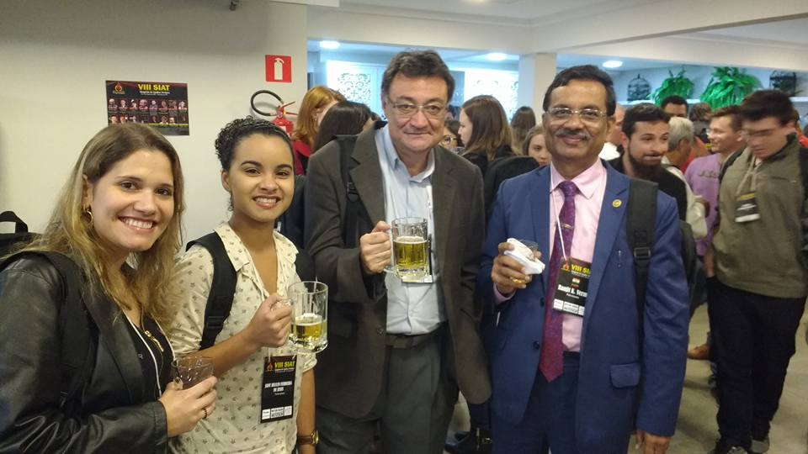
Fig. 1 : R K Verma and Eder Cavelheiro and with Brazilian researchers

Name of the author who will present the paper at the Symposium should be underlined. Use A4 paper with margins given in the template. Using the template after preparing the draft shall be convenient. Just copy from the draft and paste in the template. The abstract should not exceed 1 page.

References
[1] A A. First, B. Second and C. Third, Journal, 12 (2007) 345.
[2] B. Singh, C. D. Verma. Applications of thermal analysis. Publisher, City, 2000.
[3] G. Mettam, B. Adams, in: S.S. Jones, Z. Smith (Eds.). Introduction to the Electronic Age, E-Publishing, Inc. New York, 2009, pp. 281–304

